1st issue is website is not secure (no HTTPS protocol) Severity : High

2nd issue is website is present only in english and hindi

Concession field should be discernable in colour

Verification of human being

The summary of the trip details are not presented properly

We cannot apply passenger specific concessions if we are booking for multiple persons at the same time .

We can enter >10 digit mobile number

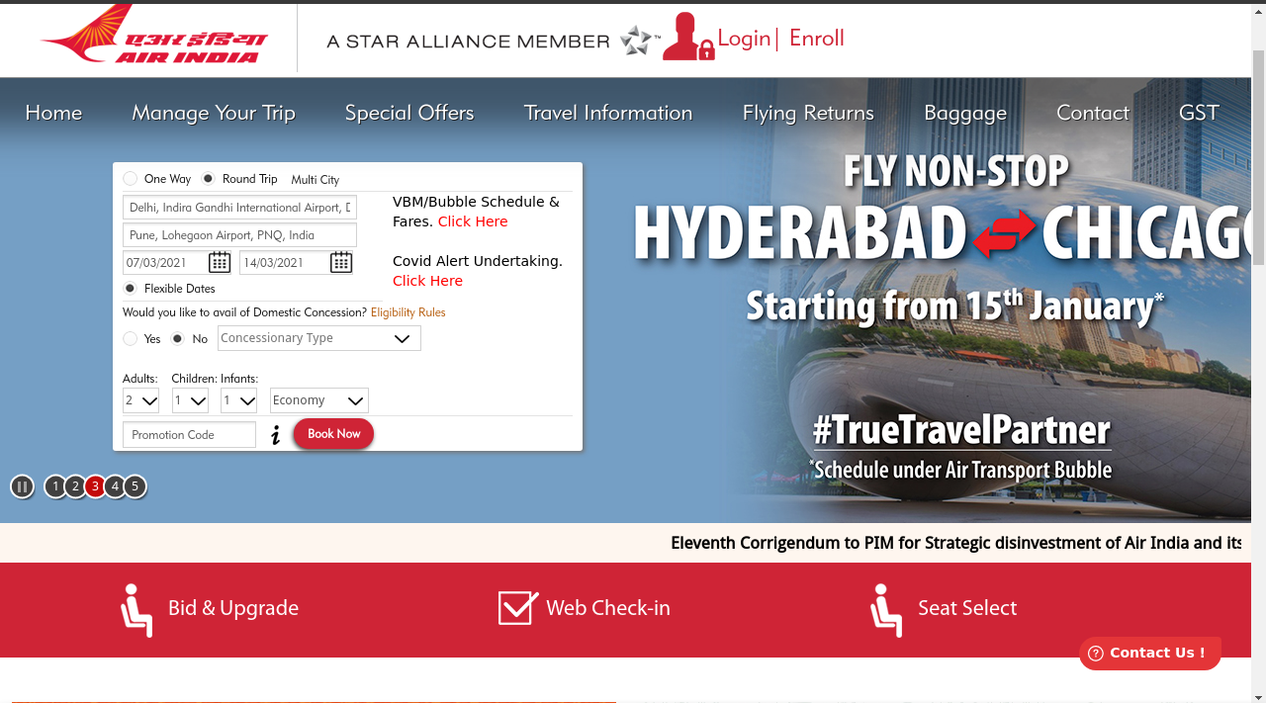

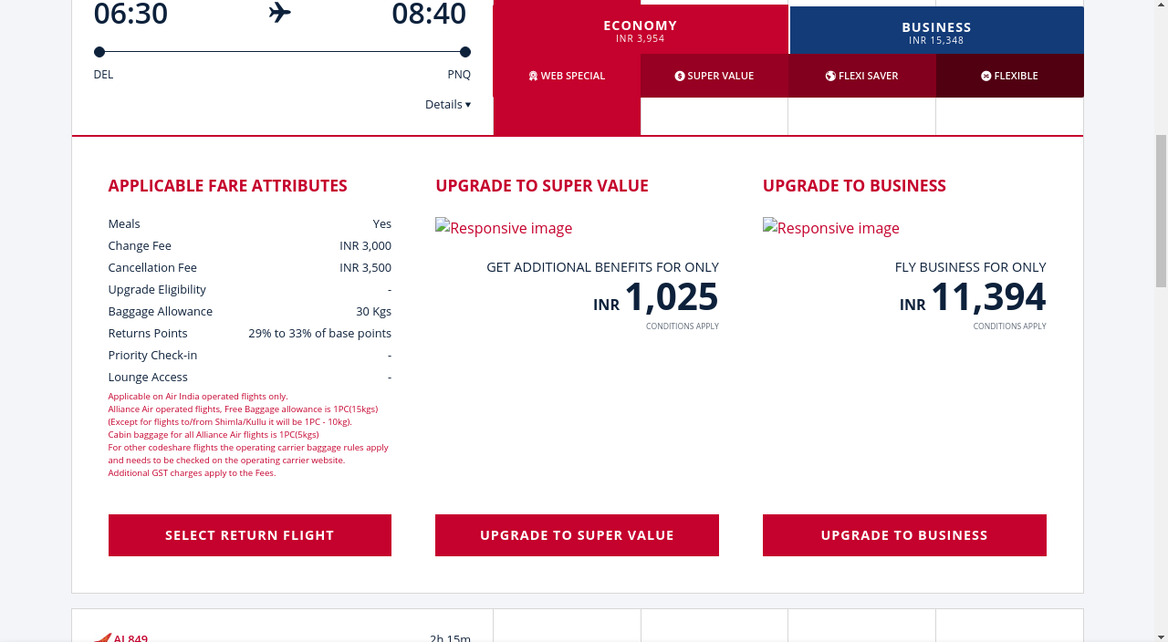

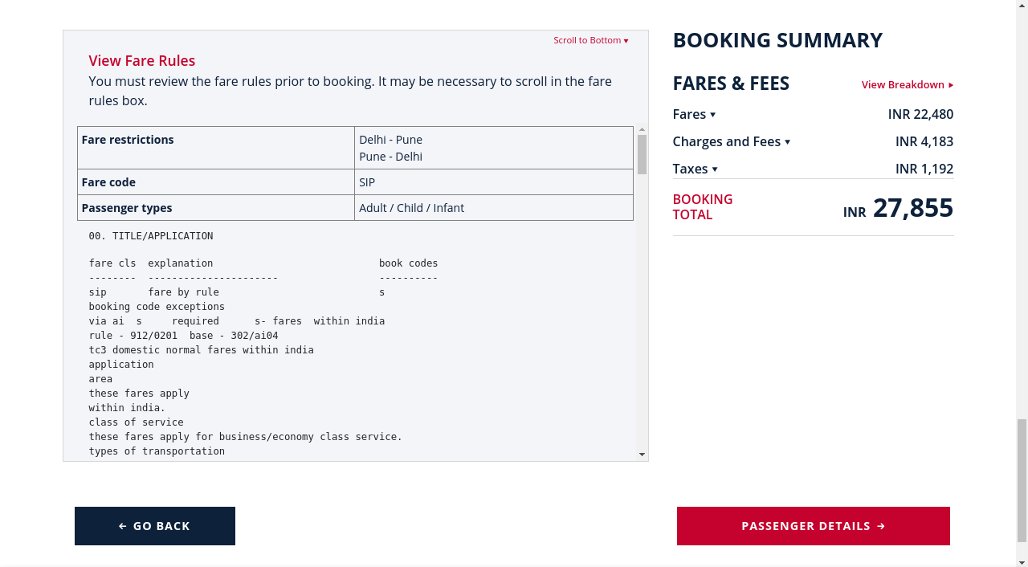

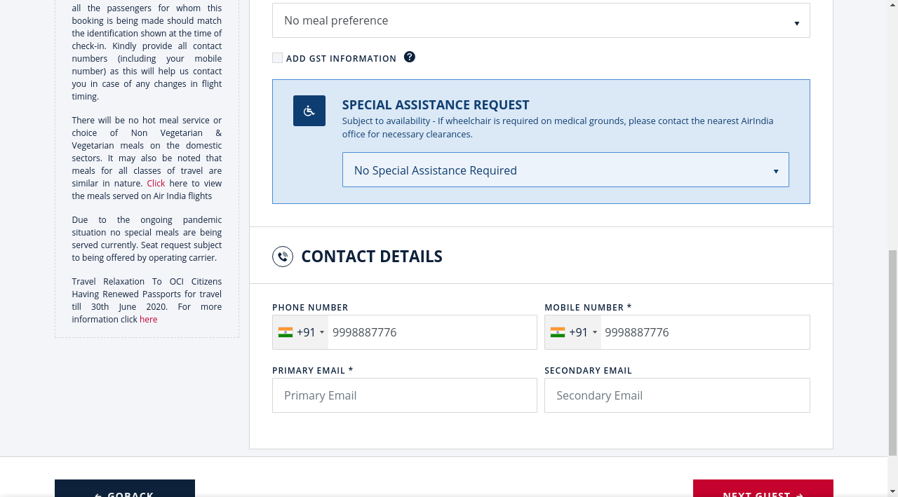

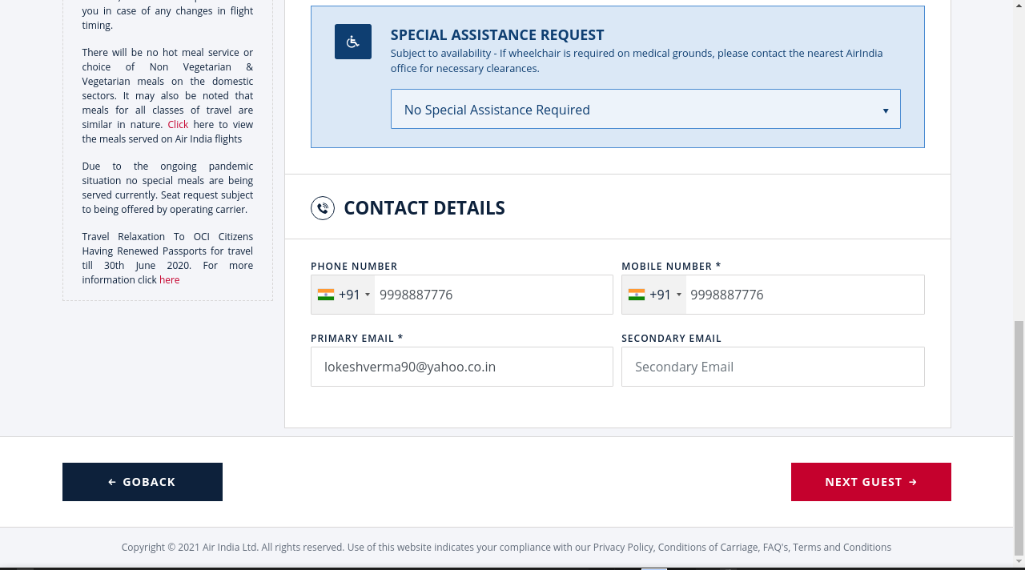

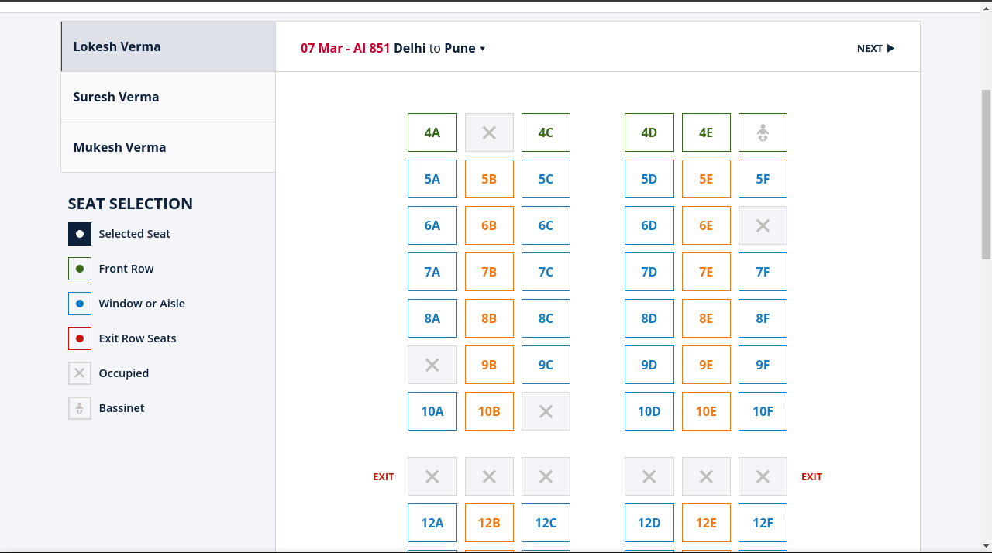

Pricing info not properly presented

GROUP-19

Aaryaansh Agarwal(aaryaansh20003@iiitd.ac.in)

Deepam Sarmah (deepam20050@iiitd.ac.in)

Ishmeet Singh Saluja ishmeet20511@iiitd.ac.in

Utkarsh Pal(utkarsh20144@iiitd.ac.in)

Prachi (prachi20098@iiitd.ac.in)